Sample Paper – 2008
Class – X
Subject - Mathematics

Set – 1
[Full marks – 80 ] [Time – Two hours and a half]
Section – I [ 40 Marks]
Attempt all questions from this section
Q.1(a) When the rate of sales tax is increased from 4.5% to 7%, a car dealer sells a car for Rs.3,750 more. Find the quoted price of the car. (3)
(b) Find the mean proportion of x – y and x³ – x²y. (3)
(c) Ram borrowed Rs.2,500 from Shankar at 12% per annum C.I. After 2 years, he gave Rs.2936 and a radio to Shankar to clear the account. Find the cost of the radio. (4)

Q.2(a) Find the value of p and q, if x² – 1 is a factor of x⁴ + px + 2x² – 3x + q. (3)
(b) Find the median of :
19, 25, 59, 48, 35, 31, 30, 32, 51. If 25 is replaced by 52, find the new median. (3)
(c) In a quadrilateral ABCD, AB = AC = AD. Show that :
∟BAD = 2 (∟CBD + ∟CDB). (4)

Q.3(a) Anupam deposits Rs.1,600 per month in a recurring deposit accountfor three years at the rate of 9% p.a. simple interest. Find the amount she will get at the time of maturity.
(3)
(b) In the given fig., ABC is an equilateral triangle inscribed in a circle of radius 4 cm. Find the area of the shaded region. (3)
Fig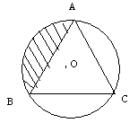
(c) (i) Plot A (2,3) and B (4,5) on a graph paper.
(ii) Reflect A, B in the y-axis to A’, B’. Plot these points on the same graph.
(iii) Write down :
(p) the geometrical name of the figure ABB’A’.
(q) the measure of the angle ABB’
(r) the image B” of B when B is reflected in the point (0,0). (4)

Q.4(a) Evaluate :
Sin²(90º – A) + cos²(90º – A) + sec²(90º – A) – tan²(90º – A). (3)
(b) x + 1/2 ≤ 5 – x /2 ≤ 7/2, x є R. (3)
(c) The mean of the following frequency table is 50. But the frequencies f₁ and f₂ in the classes 20 – 40 and 60 – 80 are missing. Find the values of f₁ and f₂.
Class | 0 – 20 | 20 – 40 | 40 – 60 | 60 – 80 | 80 – 100 | Total
Frequency | 17 | f₁ | 32 | f₂ | 19 | 120

Section – II (40 Marks)
Answer ANY FOUR questions.
Q.5 (a) In the given fig., O is the center of the bigger circle and AC is its diameter. Another circle with AB as diameter is drawn. If AC = 54 cm and BC = 10 cm, find the area of the shaded region. (3)
Fig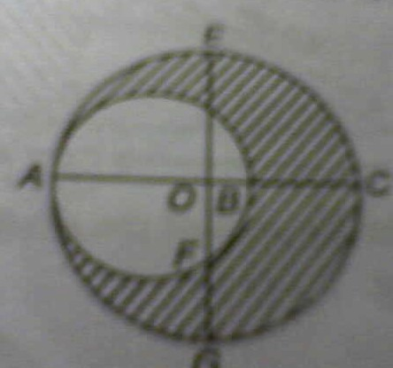
(b) If cosec θ – sin θ = a, sec θ – cos θ = b, show that a²b² (a² + b² + 3) = 1. (3)
(c) Mr. Mohan Chand had a Saving Bank Account in a bank. His passbook had the following entries :
Date 2006 | Particulars | Withdrawals (in Rs.) | Deposits (in Rs.) | Balance (in Rs.)
Jan. 07 | By cash | − | 500.00 | 500.00
Mar. 18 | To cheque | 100.00 | − | 400.00
May 22 | By cheque | − | 1,500.00 | 1,900.00
July 28 | To cash | 200.00 | − | 1,700.00
Sept. 03 | By cash | − | 1,300.00 | 3,000.00
He closes the account on 30th Oct. 2006 and receive Rs.3,043.75. Find the rate of interest per annum. (4)

Q.6.(a) In the given fig., ABC is an isosceles triangle in which AB = AC. A circle through B touches the side AC at D and it intersects the side AB at P. If D is the mid-point of AC, prove AB = 4AP. (3)
fig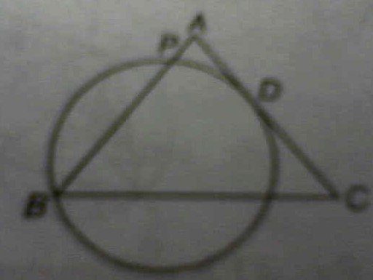
(b) If 2my – 3x = 4 and 3my + 8x = 10 are perpendicular to each other, find m. (3)
(c) Find X and Y, if X + Y = [7 0 5] and X – Y = [3 6 9] (4)

Q.7.(a) The total annual income of Ms. Shilpi, who is working in a multinational company, is Rs.7,00,000 excluding HRA. She contributes Rs.1,000 per month to her provident fund donates Rs.25,000 to the Rajiv Gandhi Foundation having a 50% exemption.Find the income tax to be paid by Shilpi in the last month of the year if she paid Rs.10,000per month as income tax for the first11 months. (6)
(b) From the top of a church spire 96 m high, the angles of depression of two vehicle on a road, at the same level as the base of the spire and on the same side of it are xº and yº, where tan xº = 3/4 and tan yº = 1/3. Calculate the distance between the vehicles. (4)

Q.8.(a) In given fig. ABC is a right angled triangle, right angle at B, AB = 6 cm and BC = 8 cm. A circle with centre O has been inscribed inside the triangle. Find the value of x.
(3)
fig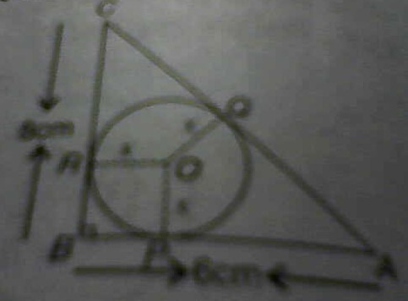
(b) A (0, 0), B (6, 0), C (4, 2) and D (2, 2) are the vertices of a trapezium ABCD and E and F are the mid-points of AD and BC respectively. Prove that EF = 1/2(AB + CD). (3)
(c) A company with 10,000 shares of nominal value of Rs.100 declares an annual dividend of 8% to the shareholders.
(i) Calculate the amount of dividend paid by the company.
(ii) Raju had bought 90 shares of the company at Rs.150 per share. Calculate the dividend he receives and the percentage return on his investment. (4)

Q.9.(a) If A = {1, 2, 3}and f, g, h and s are relations corresponding to the subsets of A×A indicated against them, which of f, g, h, and s are function and which are not.
(i) f = {(2, 1),(3, 3)} (ii) g = {(1, 2),(1, 3),(2, 3),(3, 1)}
(iii) h = {(1, 3),(2, 1),(3, 2)} (iv) s = {(1, 2),(2,2),(3, 1)} (3)
(b) Check whether x = 4 and x = 5 are solutions of the given equation :
√(x² – 16) – (x – 4) = √(x² – 5x + 4). (3)
(c) A cone of height 15 cm and diameter 7 cm is mounted on a hemisphere of same diameter. Determine the volume of the solid thus formed. (4)

10.(a) Draw an Ogive for the following frequency distribution by “Less than” method :
Marks | 0 – 10 | 10 – 20 | 20 – 30 | 30 – 40 | 40 – 50 | 50 – 60
Number of students | 7 | 10 | 23 | 51 | 6 | 3
(6)
(b) In the given fig., angle C is 90º, CD bisects angle BCA and DE is perpendicular to CA. Prove that AD/AB = CE/BC. (4)
fig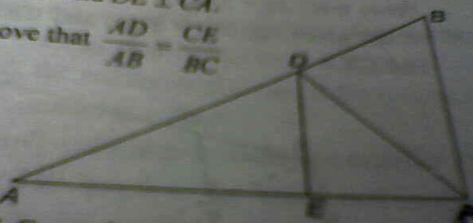

Q.11.(a) Find the circumcentre of the triangle whose vertices are (-2, -3), (-1, 0) and (7, -6).
(3)
(b) Construct a triangle ABC in which AB = 5 cm, BC = 8 cm and CA = 7 cm. Construct a circle which passes through A and B and which has BC as a tangent. (3)
(c) A train travels a distance of 300 km at constant speed, if the speed of the train is increased by 5 km/hr, the journey would have been 2 hours less. Find the original speed of the train. (4)

1. (a) Rs.1,50,000 (b) x(x – y) (c) Rs.200 2. (a) p = 3, q = – 3 (b) 32, 35 3. (a) Rs.65,592 (b) 9.824cm² (c) (iii) (p) Isosceles trapezium (q) 45º (r) (– 4, – 5)
4. (a) 2 (b) x = 3 (c) f₁ = 28, f₂ = 24 5. (a) 770 cm² (c) 5% 6. (b) m = ± 2
(c) X = [5 3 7], Y = [2 – 3 – 2 ] 7. (a) Rs.15,205 (b) 288 m 8. (a) x = 2 cm
9. (a) (iii) and (iv) are function (b) yes, yes 11. (a) (3, – 3) (c) 25 km/hr.
Best of luck.
M. P. Keshari (09434150289).

